Siamak Adeli Koodehi 46642800

Cristhyan Cardona Garcia 4666772

Matthew Colwell 4292619

Christopher Symons 46587947

Hai Hung Vu 46634010

Abstract

Does government allocate capital spending fairly according to societal need, or do electoral pressures mean that some places get more than their fair share? How can a taxpayer make sense of the spending data to decide for themselves?

Group 8

DATA7001 Introduction to Data Science

Group Project

6 November 2020

*We give consent for this to be used as a teaching resource.*

# Executive Summary

This project aimed to reveal relationships between the spatial distribution of government capital project expenditure across Queensland and the politics of the electorates in which projects are located.

The project delivered a web-based analytics tool to empower a voter to visualise capital projects, associated expenditure, and electoral political status of electorates in relation to one another and in the context of relevant population statistics.

The project also applied exploratory data analysis and statistical analysis to the same data in an attempt to investigate the possibility that electoral pressure causes expenditure decisions to deviate from what would best serve societal need.

Key take-away messages are that (1) there is some evidence that political motivation clouds government spending, and (2) there is much that could be done as an extension of this work to unlock more powerful learnings from the data: more advanced statistical techniques, temporal spending data, more reliable methods for classifying seat margin under the preferential voting system and expansion to more regions.

# Table of Contents

Executive Summary 2

Table of Contents 3

1 Defining the Problem 1

1.1 What is happening 1

1.2 How will the problem be addressed? 2

1.1 What related works exist? 2

2 Sourcing Methodology 3

2.1 Getting the data 3

2.2 Data Ingestion 3

2.3 Data ingestion of electoral boundaries 3

2.4 (Atttempt at) Data ingestion of PDF spending data 4

2.5 Making the Data Fit for Use 5

3 Making the Data Confess 7

3.1 Correlation Mining 7

3.2 Simple Linear Models 7

3.3 Logistic Model 9

3.4 Multiple Linear Model 9

4 Outcomes and Insights 13

4.1 Project outcome 13

5 Incorporation of feedback and recommendations 18

5.1 Presentation day 18

5.2 Peer review 18

6 Adherence to project pitch 20

Appendix A – References 21

Literature 21

Datasets 21

Code Libraries and Tools 21

# Defining the Problem

## What is happening

According to the 2019 Australian Election Study, public trust in democratic institutions in Australia is at the lowest it has been since the 1970s. Just 59% of Australians surveyed said they were satisfied with how democracy is working, down from a record high of 87% in 2007, and only 12% said they believed the government was run for ‘all the people’1. This displeasure with government institutions is demonstrated in Figure 1‑1.

Figure 1‑1: Trends in Australian Trust in Politicians and Government Institutions

Stories of alleged malfeasance by elected officials have filled news articles in recent years such as the now infamous Sports Rorts scandal, Barnaby Joyce’s $80M water buybacks and the Department of Infrastructure and Transports recent $30M purchase of land for the Western Sydney Airport which was valued at just $3M.

The trends above show that public is increasingly more sceptical of government’s agenda, justified by these frequent scandals. The use of big data in public domains may help to increase political awareness of concerned tax payers. Rapidly exposing and informing voters of inappropriate agenda is the most powerful tool to discourage this behaviour.

## How will the problem be addressed?

There are many forms of inappropriate behaviours a government can engage in; the type that this project aims to expose is “pork–barrelling” – the use of public funds in a manner which is designed to win elections, regardless of the needs of the people. This first phase of the project will serve as a ‘proof of concept’, focussing on the use of Queensland state funds and state elections. The data collected will include electoral maps, electoral results, the Queensland State Infrastructure Plan and census data. With this information, seats will be categorised broadly by their parties and their status as safe/marginal. From there, relationships between spending and other parameters will be explored using basic exploratory data analysis. The hypothesis of this investigation is that some relationship exists between the margin that an electorate is held by the sitting party and the spending allocated to that electorate. Any potential correlations found in the data will have a model developed to determine if there is a statistically significant relationship. Finally, a web tool will be used to convey to voters what behaviour they can expect from their elected officials.

## What related works exist?

Many groups have analysed and visualised government expenditure, and several groups in Australia and elsewhere have published analytic tools aimed at allowing a layperson to visualise government expenditure. But few of these offerings are focused on the spatial dimension of the data, and, surprisingly, that none have attempted to link expenditure data with electoral political data by using electoral boundaries to attribute an electorate to each expenditure line item.

The Truii / Advance Queenland project (qld.govspend.info) provides an interactive spatial visualisation of Queensland government expenditure. It includes informative storytelling elements. But it does not attempt to link to electoral political data.

# Getting the Data

## Sourcing the Data

To answer the project’s hypothesis and find out whether project spending is following a fair pattern, different types of dataset were gathered from various sources listed as below:

1. Queensland state election results and statistics:

This source provides data regarding State election results from 2009 to 2017 by district list. It also includes information about declared seats summary, first preference totals for each candidate and two candidate results after distribution of preferences.

<https://www.ecq.qld.gov.au/elections/election-results>

1. Queensland Spatial Catalogue – Q-Spatial:

This service is a Queensland Government initiative to provide improved public access to a variety of spatial and associated data. This source provides spatial data regarding the 93 electoral boundaries drawn in 2017.

[http://qldspatial.information.qld.gov.au/catalogue/custom/detail.page?fid={079E7EF8-30C5-4C1D-9ABF-3D196713694F}](http://qldspatial.information.qld.gov.au/catalogue/custom/detail.page?fid=%7b079E7EF8-30C5-4C1D-9ABF-3D196713694F%7d)

1. The Queensland government open data portal provides data on current and future Queensland government capital works building projects undertaken across Queensland. This dataset is a CSV file with more than 20 attributes such as the title department and the total estimated cost

<https://www.data.qld.gov.au/dataset/b518dada-3d2a-4d85-bd2c-febe197863c7/resource/410fb21f-8c5a-43a1-8b57-a74a3329d1d0>

1. Census Data, based on LGA (local Government areas), is owned by the Australian Bureau of Statistics. 2016 Census data consists of more than 15,000 features for 89 State Electoral Divisions. Based on its metadata, data related to population, income, education level, employment rate and methods of travel to work were selected for modelling purposes. <https://www.abs.gov.au/websitedbs/D3310114.nsf/Home/2016%20search%20by%20geography>

<https://www.abs.gov.au/AUSSTATS/abs@.nsf/DetailsPage/1270.0.55.001July%202016>

<https://www.abs.gov.au/AUSSTATS/abs@.nsf/DetailsPage/1410.02014-19?OpenDocument>

## Data Ingestion

The first step to ingest the collated data was to find out whether the data was consistent or not and how all data from different sources could be linked together.

### Election Results

Election results by electorate are available on the ECQ website for all elections dated back to 2009. First preference votes are presented on the website at directories following the syntax “elections/state/State2017/results/district1.html” while the two candidate preferred results are available at the directory “elections/election-results/2017-state-election” in the form of a PDF for each district. The first preference results were collected by implementing web scraping methods and the PDFs were collected through web scraping and then read for their results. Web scraping was done using the python library BeautifulSoup and the reading of the PDFs was doing using PyPDF2. These implementations are available in the files ECQ scraping.py and pdf_scraper.py.

### Electoral boundaries

A set of spatial descriptions of all 93 Queensland electorates were identified at the publicly available Queensland Spatial Catalogue (QSpatial). Each electorate in this data set is represented by a polygon with latitude and longitude coordinates. Upon inspecting the published metadata, it was identified that the data was available in several geospatial vector data formats including the commonly used ESRI shapefile format (.shp), for a handling method was implemented in R. This method uses libraries sp, rgdal, rgeos, and ggmap, and is demonstrated in accompanying Jupyter notebook find_electorate_by_latlong.ipynb. Some complexities were encountered with the gContains()function reporting warnings about its arguments (spatial point and polygon) having inconsistent projection/coordinate system. It was determined that efficiently resolving this inconsistency would likely require geospatial expertise so the suppressWarnings()method was use to simply suppress these warnings. It was checked and confirmed by testing that, notwithstanding the warning, the function call correctly and reliably returns the correct true/false value.

One of the attributes in the infrastructure dataset is the physical address of each project. By deploying the ggmap library in R, the longitude and latitude of every project could be retrieved from its physical address and consequently their corresponding electoral district could be determined.

### Spending data

Recent spending data was located in the Queensland Government Capital Program 2020 Update at <https://www.dsdmip.qld.gov.au/resources/plan/capital-program-sept2020.pdf> and an attempt to ingest the tables in this document was made using R. Some success was found in doing so with the R libraries pdftools and tm but the solution relied on reading each page of the document into an array of each piece of text with its horizontal and vertical position, and then attempting to stitch these pieces together into a table. The resulting dataframe would have required substantial manual cleaning to be fit for use because of spacing inconsistencies in the document tables. This effort was abandoned when an alternative dataset, available in comma separated value (.csv) format, was found.

As part of this effort a Python script was developed to scrape the suburb index from the Australia Post website, for use in searching the pdf data for textual locations. This is demonstrated in accompanying Jupyter notebook scrape_AP_suburb_list.ipynb.

### Census data

The census data was grouped by LGAs (local Government areas). There are three levels of local government areas and the third level has same geographical boundaries as electoral districts. Filtering helped narrow down the data and extract the census data needed for each electoral boundary.

There are 93 entities with more than 1000 major attributes in the combined files. In order to prepare the data for EDA, some attributes were merged together and unnecessary ones deleted.

Avoiding data redundancy was one of the major challenges encountered when ingesting the data. Using GitHub and creating an SQL database helped to mitigate this issue.

## Making the Data Fit for Use

To develop a modelling methodology, field linking needed to be applied so that questions such as “does margin of victory at the previous election effect government spending?” could be answered. A question such as this requires relating the spending data to the election results. A question such as “is electorate population strongly correlated to government spending?” required linking the census data with the spending data.

Unfortunately, only 77 out of 93 total electorates have spending allocated to them. This meant that 16 electorates had a 0 or null value which needed to be handled (although many projects involve multiple electorates which were removed e.g. highway upgrades). Since it was not necessarily true that those electorates had zero spending, and there is no valid way to impute their values from other electorates, they were removed from the dataset for modelling.

A similar issue occurred with the census data. Queensland electorates were redrawn prior to 2017 election, whereas the census was conducted in 2016 with the old electorates. Using a document “26.5.17_Extraordinary-Gazette_QRC-Final-Determination”, relationships between 2016 and 2017 electorates were constructed and summarised in Table 1. The new 2017 electorates’ Census data were estimated as average of all 2016 electorates, which they were drawn from. For example, Bancroft would have estimated Census data that were calculated from Murrumba, Kurwongbah, Morayfield, Pumicestone. There were some name changes, where Census data remained the same. This transformation helped reducing data loss.

|  |  |
| --- | --- |
| 2017 State Electoral Divisions (SEDs) | Drawn from equivalent 2016 SEDs |
| Bancroft | Murrumba, Kurwongbah, Morayfield, Pumicestone |
| Bonney | Southport, Broadwater |
| Cooper | Ashgrove |
| Hill | Dalrymple |
| Jordan | Bundamba, Inala, Algester, Lockyer, Logan |
| Kurwongbah | Kallangur |
| Macalister | Waterford, Coomera, Albert, Redlands |
| Maiwar | Mount Coot-tha |
| Miller | Indooroopilly, Yeerongpilly |
| McConnel | Brisbane Central |
| Ninderry | Noosa, Nicklin, Buderim, Maroochydore |
| Oodgeroo | Cleveland |
| Scenic Rim | Beaudesert |
| Theodore | Albert |
| Toohey | Sunnybank |
| Traeger | Mount Isa |

Table 1: 2016 and 2017 SED Comparison

Census population data was combined into three groups by age, which are 0-20 year-old (Under_Age), 21-65 year-old (Working_Age) and over 65 year-old (Retired) groups. This transformation was based on the understanding that each age group might have different social needs, which might impact the government’s spending. For example, public health, transport infrastructure, education needs were believed to differ amongst the groups. The count data of each group was calculated as a proportion of total population for each electorate. Therefore, during modelling stage, one of the groups (Under_Age) was excluded to avoid collinearity with the other two (i.e. Under_Age + Working_Age + Retired = 100%).

Finally, for data preparation, all spending and income data needed to be transformed to its natural logarithm to linearise the data.

# Making the Data Confess

## Correlation Mining

The first step towards making the data confess was to test the project’s hypothesis by conducting an Explanatory Data Analysis. Figure 3‑1 below shows the outcome of this exercise for some key variables; for the purpose of this analysis, the most important row in the “Log Spending” row.

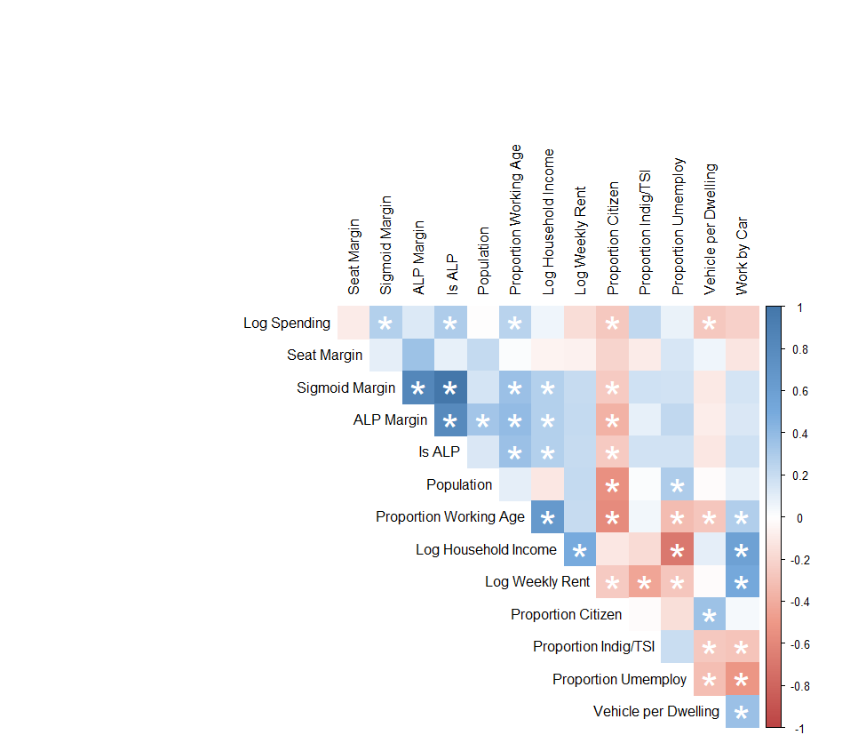

Figure 3‑1: Preliminary Correlation Matrix. Significant correlations (p > 0.05) denoted with *.

## Simple Linear Models

The original goal of this analysis was to determine if evidence exists for pork-barrelling in the Queensland electorates. The hypothesis was that electorates won on low margins would have increased spending. Fortunately for the populous, there is only weak evidence that this is the case. This is detailed in Figure 3‑2 below.

Figure 3‑2: Linear Models Detailing Relationship between Spending and Seat Margins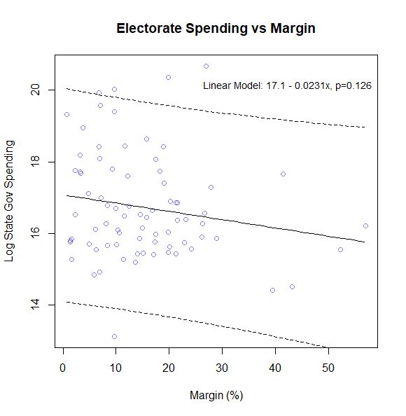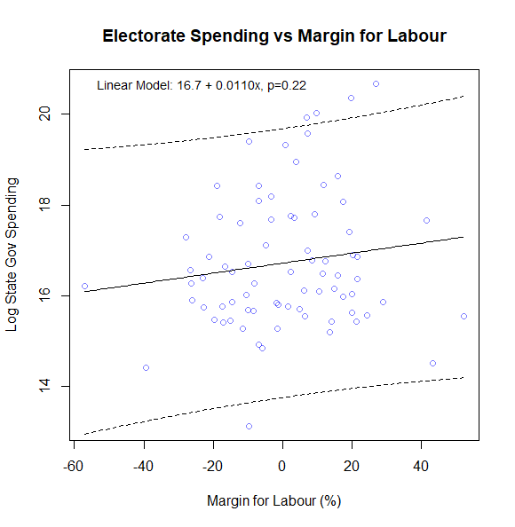

Unfortunately, there is moderate evidence that Labour, the current party in power who controls the state budget, is more likely to spend in seats which they won in 2017. This is shown in detail in Section 3.3.

Because of the number of feature variables compared, several spurious relationships were identified. The strongest correlation by p-value was between spending and the proportion of the population who walks to work. However, these relationships did not satisfy the assumptions of the linear model, as seen in Figure 3‑3 below.

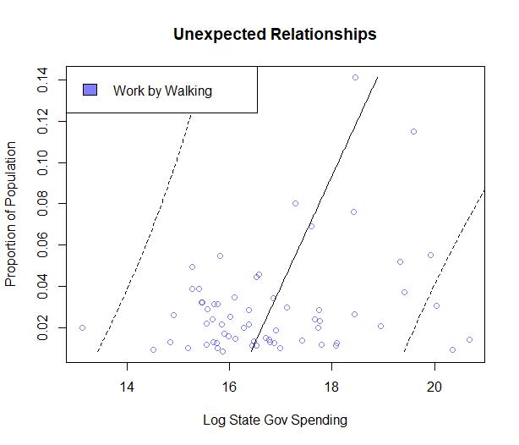

Figure 3‑3: Linear model for spending as a predictor of the proportion of the population who walks to work

## Logistic Model

From Section 3.2 it can be seen that a weak negative relationship exists between spending and the seat margin, suggesting weak evidence for the original hypothesis. However, Sigmoid Margin, which is a transformation of the ALP Margin variable, has statistically significance. Since the ALP is the party in power, it is somewhat concerning that they could potentially be spending more heavily in electorates where they won. To illustrate this, a logistic model was developed and is shown below in Figure 3‑4.

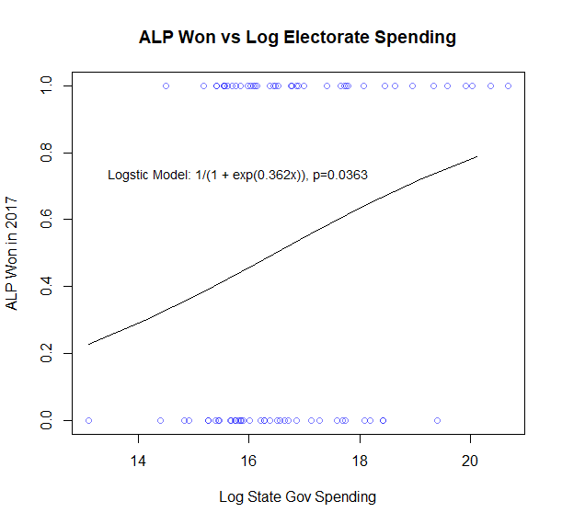

Figure 3‑4: Logistic Model for Spending as a Predictor for ALP Winning Electorate in the 2017 Election

## Multiple Linear Model

A multiple linear regression model was also constructed using seven predictors, namely Working_Age, Retired, logarithm of Median weekly family income, number of full-time employment, isALP and ALP_Safety_Ranking_Margin. ALP_Safety_Ranking_Margin was formulated based on the two-party preferred election results. As the voting preference ranking was unclear, assumptions were made such that following logics were applied:

* Safety is ranked from 0 to 5, where 0 means ALP dominating an electorate and 5 means ALP being a minority
* If ALP was voted the first preferred party and higher than the second preferred party by a margin that was greater than 10%, safety ranking is 0
* If ALP was the first preferred party and a margin was between 6-10%, safety ranking is 1
* If ALP was the first preferred party and a margin was lower than 6%, safety ranking is 2
* If ALP was not the first preferred party and the first preferred party had a margin less than 6%, safety ranking is 3
* If ALP was not the first preferred party and the first preferred party had a margin greater than 6% and less than 10%, safety ranking is 4
* If ALP was not the first preferred party and the first preferred party had a margin greater than 10%, safety ranking is 5

These assumptions on safety ranking need to be validated by a political science expert; in this project, the ranking was only used to explore if there was any relationship with the government’s spending. The model’s assumptions were validated by checking various plots (Figure 3‑5, Figure 3‑6 and Figure 3‑7). The assumptions are considered reasonably held.

Figure 3‑5: Multilinear Model Residual vs Fitted Values

Figure 3‑6: Multilinear Model QQ Plot

Figure 3‑7: MLM Influential Data - Cook's Distance

The multiple linear regression model’s results are shown below.

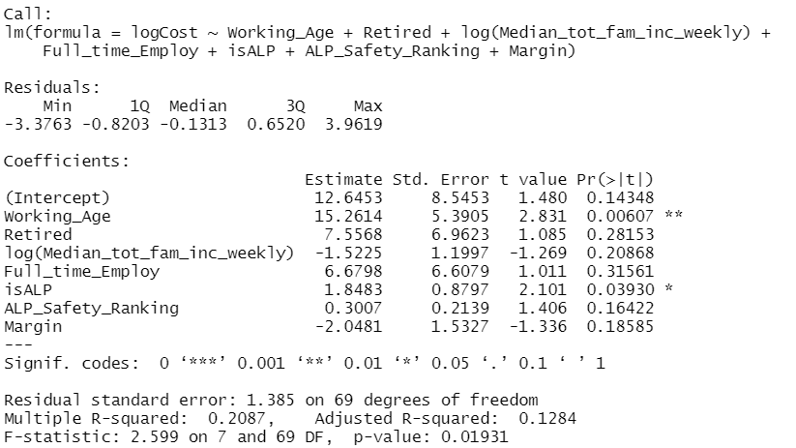

Based on F-statistic (p-value of 0.019), there is a moderate evidence against the null hypothesis, which suggests there is a relationship between logCost and the predictors, mainly Working_Age and isALP. Figure 3‑8 shows a reasonable linearity between logCost and Working_Age.

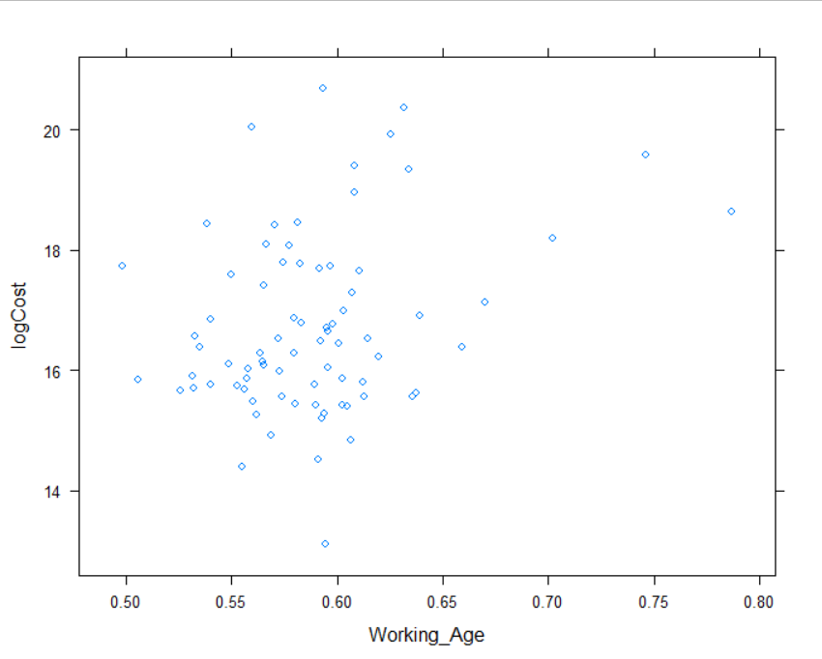

Figure 3‑8: Linearity betwen logCost and Working_Age

# Outcomes and Insights

## Project outcome

To communicate the outcome of this project, a web tool was developed and is located at [[https://data7001group8.com]](https://data7001group8.com/). The data is displayed in two different maps. The first map is based on the electorates while the second is based on LGAs. The web tool also depicts the distribution of projects and their locations on each electoral district. Expenditure and the total estimated cost of each project are shown as they relate to one of 13 different departments and the relationship between projects with population of each region. The web tool allows for the user to drill down by electorate to further investigate election results or view where spending is concentrated (either by location or department). The user can also zoom out and visualise the result of state elections dating back to 2009. These features are illustrated in Figures

Figure 4‑1: Web tool showing population by LGA

Figure 4‑2: Web tool zoom out functionality being used to show historical election results

Figure 4‑3: Web tool showing 2017 state election results

Figure 4‑4: Web tool drill down applied showing spending by department for the Brisbane LGA

Based on findings of the regression models, there was no clear evidence of pork-barrelling theory which suggested the government would allocate more budget to swing electorates. However, there is a moderate evidence for political motivation where the winning party allocated more budget to their won electorates. There is also an evidence that more spending was allocated to electorates that have higher proportion of working age population. However, the total population size and median household income have no correlation to spending.

The project team was aware that the data was only a snapshot of the government’s spending, election results and Census data. Due to time limitations and significant effort to gather the required data, the team decided it would be more efficient to explore the snapshot data to find features that are the most relevant in understanding the government’s spending. Based on these findings, the project’s scope and data would then be extended, with the same methodology applied, if time allowed.

By following the data science process, defining a human centre problem, getting a data and making sure it is fit for use and then making the data confess, some evidence was found to support the hypothesis of political motivation when allocating to government spending. A secondary correlation between spending and the working age group (21-65 years old) was found. However, no correlation was shown to exist between spending and the population size or an electorate’s median household income.

To improve the understanding of factors which influence government spending, it is suggested that more sophisticated statistical techniques be used to widen the scope of the data.

# Incorporation of feedback and recommendations

We are grateful to have received comments from Professor Shazia Sadiq and Dr Thomas Taimre after our presentation given on 28/10/2020, and also peer review comments from nineteen (19) of our classmates at a later date.

## Presentation day

Comments received from the teaching team on presentation day are as follows, interspersed with our responses in italics:

* It was not clear whether the statistical analyses you presented were for a certain specific year or for a range of years.
  + *Agreed. We have taken care to identify in Section 2 the time period to which our source data applies.*
* You may be able to get some stronger conclusions if you look at data from previous years. This could allow you to consider a new variable: election year yes/no.
  + *We agree that this would add much richness to the data and open up new possibilities to draw more and more convincing inferences. Despite an extensive search for time series / historical data, we were limited by availability of open data here. No action.*
* Recommend you more clearly support your conclusions with learnings from the data i.e. draw out the data driven aspect.
  + *Agreed. In our enthusiasm to maximise inclusion of interesting content, we did not retain enough detail in the conclusion section linking back to what we found in the data. Action complete: We have included more complete linking of conclusions back to data in Section 4 of the present report.*

## Peer review

We are grateful to have received peer review comments on our 28/10/2020 presentation from nineteen (19) peers. The comments have been distilled into a list, giving weight to repeated themes and to sentiments expressed as actionable, specific, and objective recommendations. The list is presented below, interspersed with our responses in italics:

* Don’t show code on your PowerPoint slides. It’s not possible to make sense of it in the time available and perhaps not even legible due to text size and resolution available.
  + *Agreed. We appreciate that 30 or 60 seconds is not sufficient to make sense of half a screen of code. This comment relates only to the presentation and does not have any bearing on the report. No action required to resolve.*
* Support your conclusions more clearly with inferences drawn from data. (Or, at least, put conclusions in the context of the data and findings.)
  + *Agreed. In our enthusiasm to maximise inclusion of interesting content, we did not retain enough detail in the conclusion section linking back to what we found in the data. Action complete: We have included more complete linking of conclusions back to data in Section 4 of the present report.*
* Link your conclusions back to aim of project / stated problem.
  + *Agreed. Similar to above item. Action complete: We have included more complete linking of conclusions back to the aim of the project in [section 4] of the present report.*
* Try to use time series / historical spending data. (Including because election year yes / no might be an interesting dependent variable.) This may allow more and more convincing inferences from data.
  + *We agree that this would add much richness to the data and open up new possibilities to draw more and more convincing inferences. Despite an extensive search for time series / historical data, we were limited by availability of open data here. No action.*
* State the topic of your project clearly and at the start.
  + *Agreed. Action complete: We have stated the topic on the cover page, in the executive summary, and in Section 1 of the present report.*
* Identify your Storytelling with Data section more clearly. It seemed to be missing or perhaps blended with other sections.
  + *Understood. In our enthusiasm to use the inverted pyramid storytelling structure, we perhaps deemphasised our Storytelling with Data component by splitting it between the web tool demonstration and an integrated part of the Making the Data Confess section. Action complete: We have included a more distinct storytelling in Section 4.1 in the present report.*

# Adherence to project pitch

There was no substantial deviation from the initial pitch given on 16/09/2020 with materially impacted the project.

In the pitch a Core and an Enrichment array of datasets were identified; it was explained that the project planned to work initially with the Core datasets, and then, if time were to permit, look into the Enrichment datasets. Time did not permit, and the project remains limited to the Core datasets. This ensured that excessive resources were not spent getting, cleaning, and transforming data, to the detriment of later parts of the data science process.

# Team coordination and communication

The public health imperative to adopt a mostly work-from-home mode of operating presented unique challenges. The team had few full in person team meetings instead using free and low-cost technology platforms here to establish a smooth and regular flow of communication.

* The team held weekly Zoom telephonic meetings, including the use of screensharing to show and discuss coding, statistical, written work.
* The team used a GitHub repository to share files including documents, code, minutes of meetings, and notes.
* The team established a cloud-based relational database and management system (MySQL with phpMyAdmin) to provide a single point of truth for our datasets and to allow us to share intermediately processed data.

Maintaining good communication allowed the project team to coordinate week-by-week efforts and plan ahead to deliver against milestones.

# Appendix A – References

## Literature

[1] <https://australianelectionstudy.org/> - REFERENCE TO BE CORRECTLY DETAILED

Queensland Redistribution Commission 2017, Queensland Government Gazette Extraordinary, Queensland Redistribution Commision, <https://www.ecq.qld.gov.au/__data/assets/pdf_file/0021/4944/26.5.17_Extraordinary-Gazette_QRC-Final-Determination.pdf>

## Index of Code, Libraries and Datasets

|  |  |
| --- | --- |
| Item | Description |
| Code | |
| find_electorate_by_latlong.ipynb | Searches electorate dataset for a location. Refer to Section 2.3. |
| scrape_AP_suburb_list.ipynb | Scrapes the suburb index from the Australia Post website for use in searching the pdf data for textual locations. Refer to Section 2.4. |
| ECQ scraping.py | Web scraping script which returns tabulated first preference voting data with the fields Year, Electorate, Candidate Name, Party, Vote Total. |
| pdf_scraper.py | PDF ingesting script which returns the two candidate preferred election results with the fields Year, Electorate, Party, Vote Total. |
|  |  |
| Libraries | |
| a |  |
| BeautifulSoup | Python Library used for web scraping. |
| PyPDF2 | Python Library used for reading PDF files. |
|  |  |
| Datasets | |
| election_results.csv | Derived from ECQ scraping.py script. |
| election_results_two_preferred.csv | Derived from pdf_scraper.py script. |